|  |  |
| --- | --- |
| Date | 15 March 2024 |
| Team ID | xxxxxx |
| Project Title | xxxxxx |
| Maximum Marks | 4 Marks |

# Initial Model Training Code, Model Validation and Evaluation Report

The initial model training code will be showcased in the future through a screenshot. The model validation and evaluation report will include classification reports, accuracy, and confusion

matrices for multiple models, presented through respective screenshots.

# Initial Model Training Code:

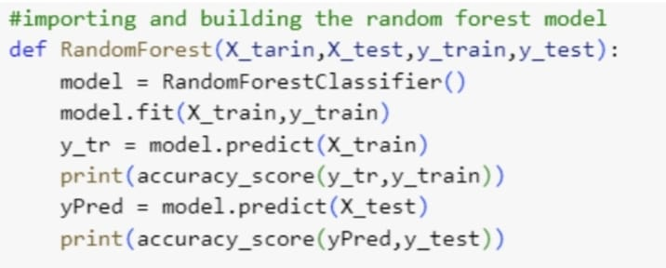

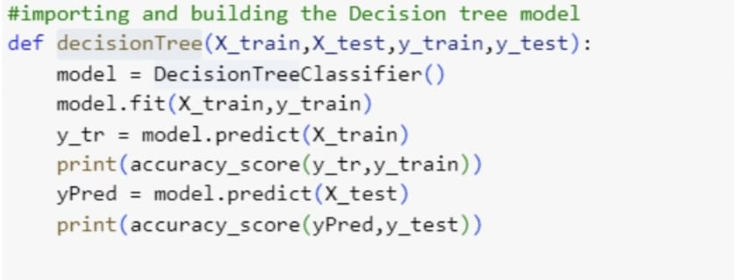

**Model Validation and Evaluation Report:**

|  |  |  |  |
| --- | --- | --- | --- |
| **Model** | **Classification Report** | **Accuracy** | **Confusion Matrix** |
| Random forest |  | 75% |  |
| Decision tree |  | 80% |  |
| … | … | … | … |